User Introduction to Dumang Keyboard
- Introduction
Introduction to Dumang Keyboard interface and basic functions
  - Main Interface
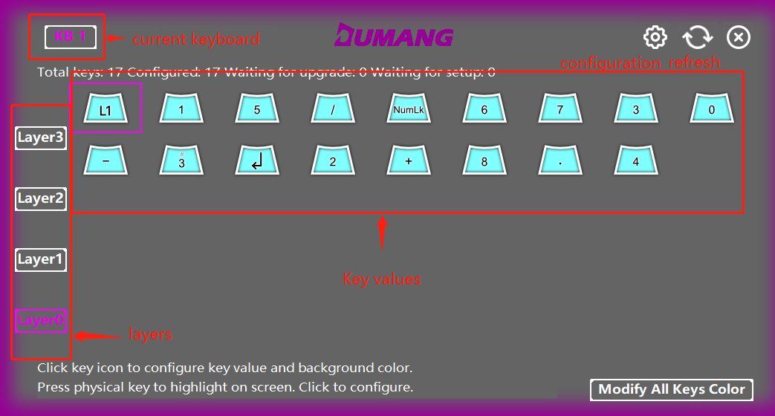
- When the software refreshes, a red dot will appear on the settings logo as shown: 

- When the mouse hovers over a button, the corresponding physical button will flash to prompt the user as shown:
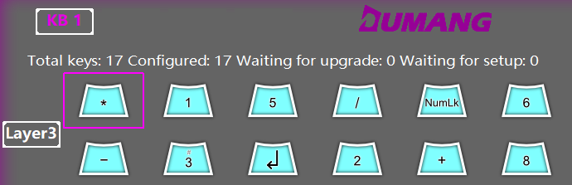

- When you press a button on the physical Dumang Keyboard, the button that was pressed will enlarge on the driver software interface as shown:
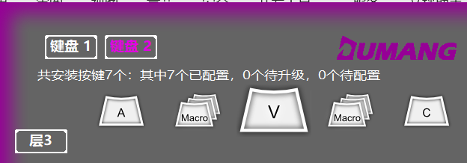
  - Setting Interface
- When no update is available:
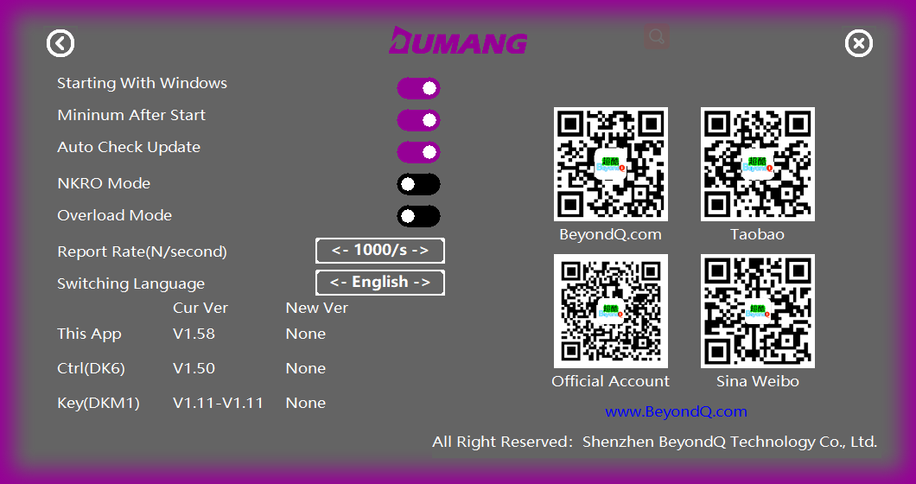

- When an update is available:
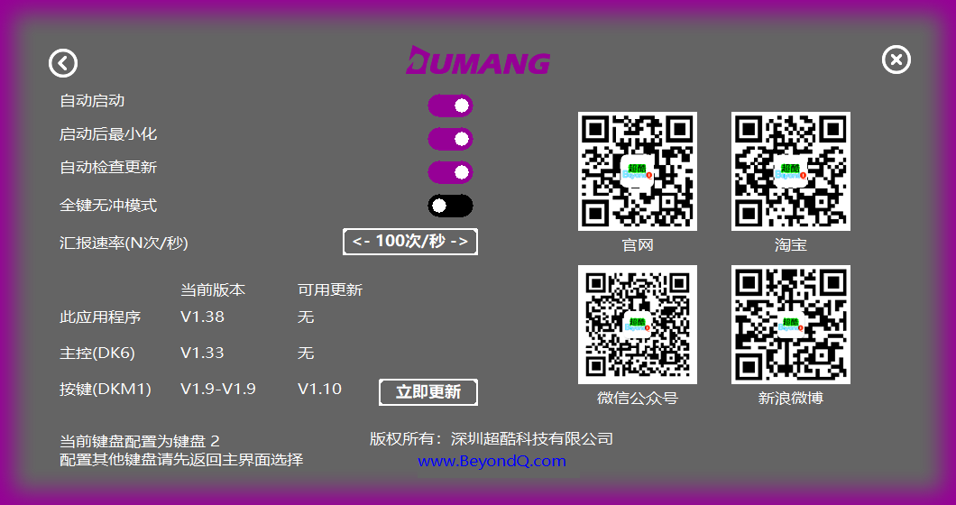

- By turning on the Auto update option, you can update the software automatically.

  - Configuring button key values
- You can start configuring your Dumang Keyboard button key values by entering the configure page via the main page.
- Left click on the key you wish to configure and after configuring, it will automatically return the user to the main interface.
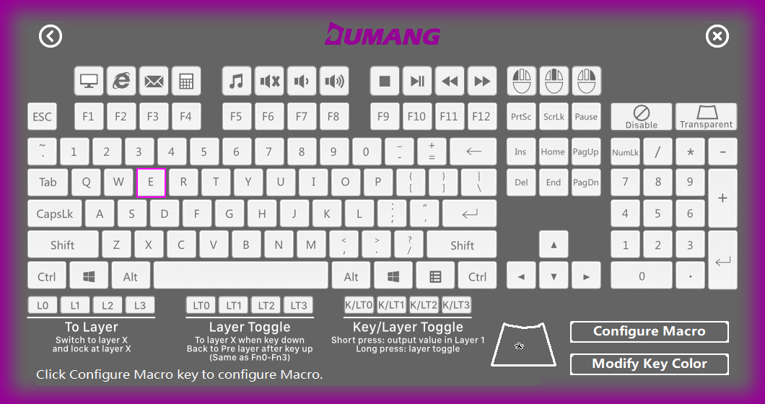

- Click on the “Macro Configuration button again to record, edit and save the macro configuration.

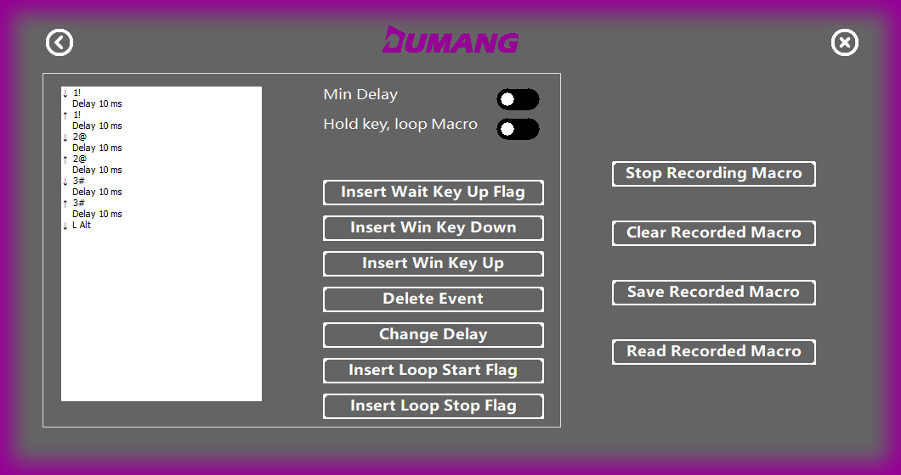

- Use of Layers
- The Dumang Keyboard supports 4 layer keys, which allows each button to be able to be configured with 4 different key values and the layered bottom can be used conveniently to expand the keyboard functions.

- In addition, the Dumang Keyboard supports 3 different slice functions where one slice can be configured and operate as a macro. They are:
  - Lock Slice – Lx
  - Temporary Slice – Ltx
  - Button / Temporary Slice – K/LTx

- Indication of layer colour. (Bottom plate logo)
  - 0 Layer: White
  - 1 Layer: Red
  - 2 Layer: Green
  - 3 Layer: Blue

  - Configuration of key values of each layer
- Click on “Layer 0” button to configure the key value of Layer 0
- Click on “Layer 1” button to configure the key value of Layer 1
- Click on “Layer 2” button to configure the key value of Layer 2
- Click on “Layer 3” button to configure the key value of Layer 3

  - Temporary Slice (LTx)
- For example: A user can combine 1,2,3…9, 0 which is a total of 10 digits and F1-F10 using the slice key ASDFGHJKL as the key output. By using the temporary slice, a user can reduce the number of physical buttons as seen on the above example.
- By doing this, the number of physical buttons required now is 10+2 (10 Character Keys, 2 Slice Keys) which is greatly reduced compared to the original 30 buttons.
- How do you do it?
Layer 2 | F1 | F2 | F3 | F4 | F5 | F6 | F7 | F8 | F9 | F10
Layer 1 | 1 | 2 | 3 | 4 | 5 | 6 | 7 | 8 | 9 | 0
Layer 0 | A | S | D | F | G | H | J | K | L | ;

- Configuration method = Configure LT1 (Layer 0 value coordinate with LT1) and configure LT2 (Layer 0 value coordinate with LT2).
- Following the table above:
  - Layer 0 = A, Layer 1 = 1, Layer 2 = F1
  - Layer 0 = S, Layer 1 = 2, Layer 2 = F2
  - so on and so forth…
- This will cause:
  - When button A is pressed, A will be output and when A is pressed, S will be then pressed and be output.
  - When LT1 + A is pressed, 1 will be output and when LT1 + S is pressed, 2 will be then pressed and be output
  - When LT2 + A is pressed, F1 will be output and when LT2 + S is pressed, F2 will be then pressed and be output.

  - Locked Slice (Lx)
Click to switch to the corresponding configuration layer: Locked Slice
- Example 1:
  - Configure a circular slice button and change Layer 0 to Layer 1 by pressing it. Press it again to change it to Layer 2, then press again to Layer 3 and press it the last time to change it to Layer 0.
  - Layer 0 key value will be configured as L1
  - Layer 1 key value will be configured as L2
  - Layer 2 key value will be configured to L3
  - Layer 3 key value will be configured to L0

- Example 2:
  - A public keyboard can be made available for 4 people, but their requirements for the keyboard layout are different.
For example, User Ala uses a Traditional arrangement method
~ | 1 | 2 | 3 | 4 | ...
Tab | Q | W | E | R | ...
Caps | A | S | D | F | ...
Shift | Z | X | C | V | ...
Ctrl | Win | Alt | Space |  | ...

User Bill wants Win and Ctrl key to change position
~ | 1 | 2 | 3 | 4 | ...
Tab | Q | W | E | R | ...
Caps | A | S | D | F | ...
Shift | Z | X | C | V | ...
Win | Ctrl | Alt | Space |  | ...

User Chris wants Caps and Ctrl key to change position
~ | 1 | 2 | 3 | 4 | ...
Tab | Q | W | E | R | ...
Ctrl | A | S | D | F | ...
Shift | Z | X | C | V | ...
Caps | Win | Alt | Space |  | ...

User Damon wants Shift, Ctrl, Caps key to all change position
~ | 1 | 2 | 3 | 4 | ...
Tab | Q | W | E | R | ...
Shift | A | S | D | F | ...
Ctrl | Z | X | C | V | ...
Caps | Win | Alt | Space |  | ...

As seen above, the keyboard is configured according to the users Ala who uses Layer 0, Bill who uses Layer 1, Chris who uses Layer 2, Damon who uses Layer 3.
According to Example 1, you can configure a loop layer key where during each user use, it will switch to the corresponding layer for the user.

- Example 3:
  - Configuring letter keys as numeric in keyboard mode.
Layer 0 as a letter key:
Q | W | E | R
A | S | D | F
Z | X | C | V
Ctrl | Alt | Space

Layer 1 configuration for numeric keypad mode:
7 | 8 | 9 | -
4 | 5 | 6 | +
1 | 2 | 3 | =
 | 0 | .

  - Button / Temporary Slice
- Usage Scenario: Short pressing Space Key and long press to change layer key.
- Button 1 configuration: Layer 0 configured to K/LT1 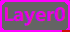 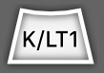, Layer 1 configured to Space key 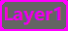 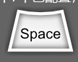
- Button 2 configuration: Layer 0 configured to A, Layer 1 configured as number F1
- When the default layer is 0, press button 2 to output A
  - Short press button 1 to output space
  - Long press button 1 to switch keyboard to Layer 1 and press button 2 to output F1.

  - Layer button and Null button

- Usage scenario 1: By pressing button A, no matter the layer, it will output A
  - Method 1: Configuring each layer with A
  - Method 2: Configure layer 0 with A. Layer 1,2 and 3 are then configured as transparent button (default at shipment) even if the current layer is 2, it will still output A.
  - No matter what layer, it will output A

- Usage scenario 2: Button A will output A at layer 0. To avoid any error during operation, no button will be output at other layers.
  - Layer 0 configured as A, Layer 1 configured as null
  - If the current layer is Layer 0, output will be A.
  - If the current layer is 1,2 or 3, when button A is pressed, there will be no output.

  - Comprehensive Application Examples
- Usage scenario

- Introduction to Macro
- The Dumang Keyboard supports Macro Recording, Editing, Saving, etc.
- The Dumang Keyboard also supports loop functions in Macro that are less than 250 cycles
- Lastly, it supports three different macro modes.
  - Single Macro mode = Press button to start sending and only send once
  - Continuous Macro = Press button to start repeatedly sending Macro outputs until button is released
  - Segment Macro = Press button to send the first half of the macro and bounce the button to send the second remaining half of the macro.
Here are some examples on various user scenarios:
  - Macro Loop Function
User Scenario: After pressing button A, press the “down arrow” 50 times.

- Step 1: Record Macro
  - For example: A, press down arrow once, press enter, press B, press down arrow once, press enter, press C, press down arrow once and enter:
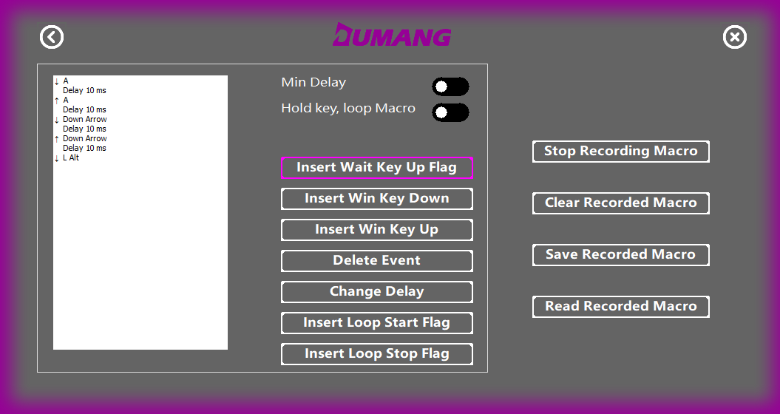
- Step 2: After recording Macro, click “Stop Recording Macro”
  - User will then click on “down arrow” and then click on “insert macro loop start sign”
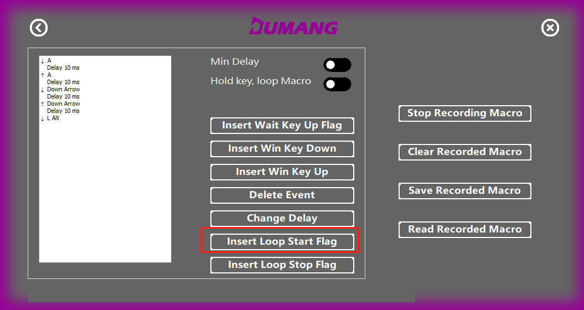
  - Enter the number of cycles as prompted and click confirm.
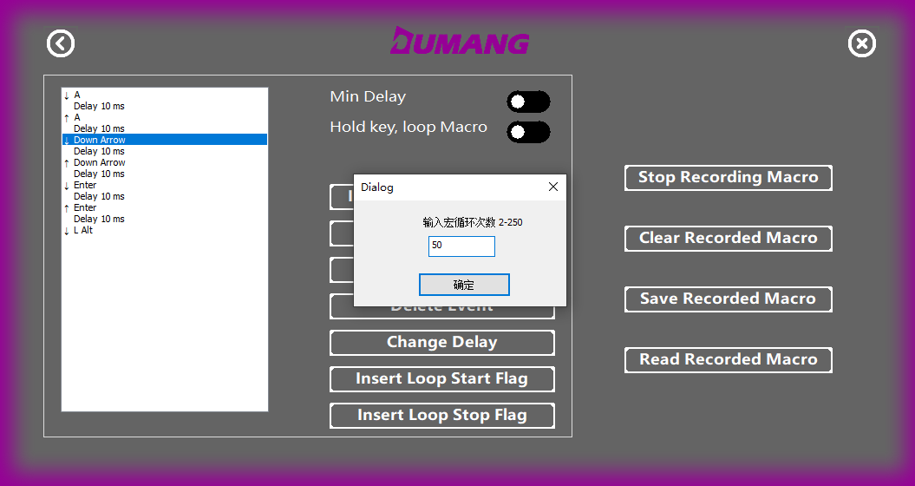

- Step 3: Click “Enter” in the next two lines of “Down arrow” and click “insert loop stop flag”.
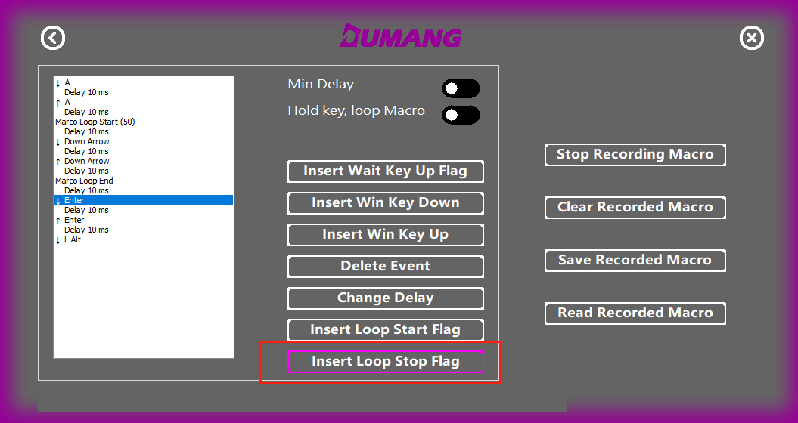

- Step 4: You will then see the down arrow wrapped up by “Macro Loop Start (xx)” and “Macro loop end”.

- Step 5: Click on “Save Recorded Macro” and you are done! You can now use the Macro.

  - Continuously Sending Macros
User scenario: After pressing down a button, continuously sending 1,2 and 3

- Step 1: Record the Macro by clicking “Start Recording Macro”
- Step 2: Press 1,2 and 3 and click “Stop recording Macro”.
- Step 3: Check “Press and hold to send Macro” and click “Save recording Macro”
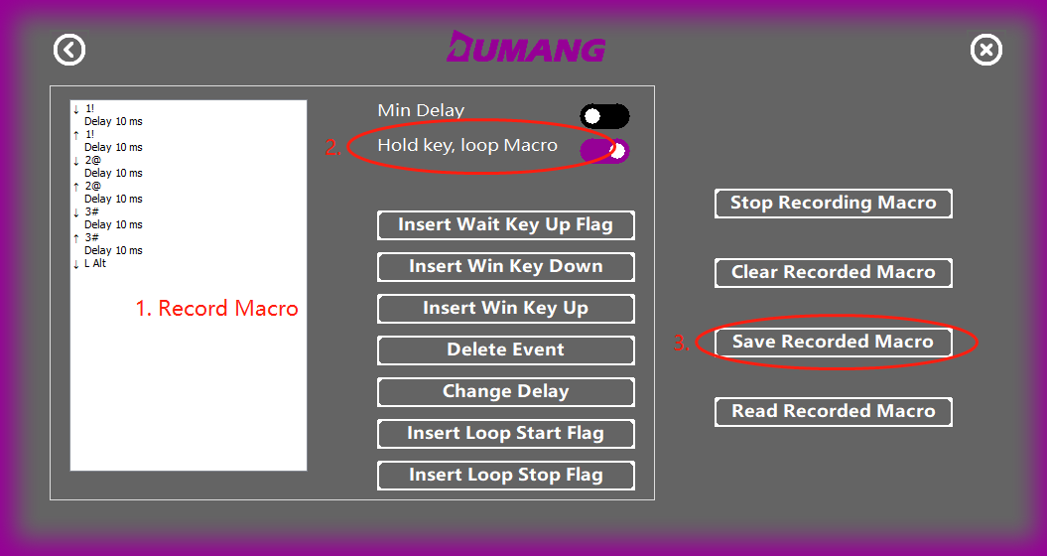

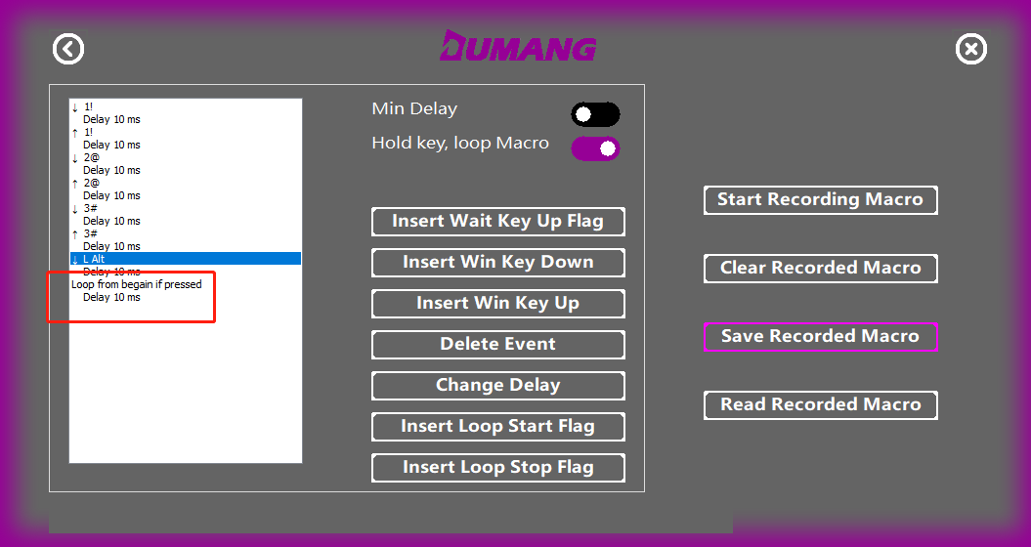
  - Segmentation Macro
User Scenario: Wish to Create a shortcut key Ctrl + Shift + Alt + S as it is very inconvenient and want to simplify the operation.
- Step 1: Click a button in the driver and click macro configuration
- Step 2: Click on “Start Recording Macro” and proceed to press Ctrl, Shift, Alt and then release the 3 keys.
- Step 3: Click on “Stop recording Macro” as shown below:
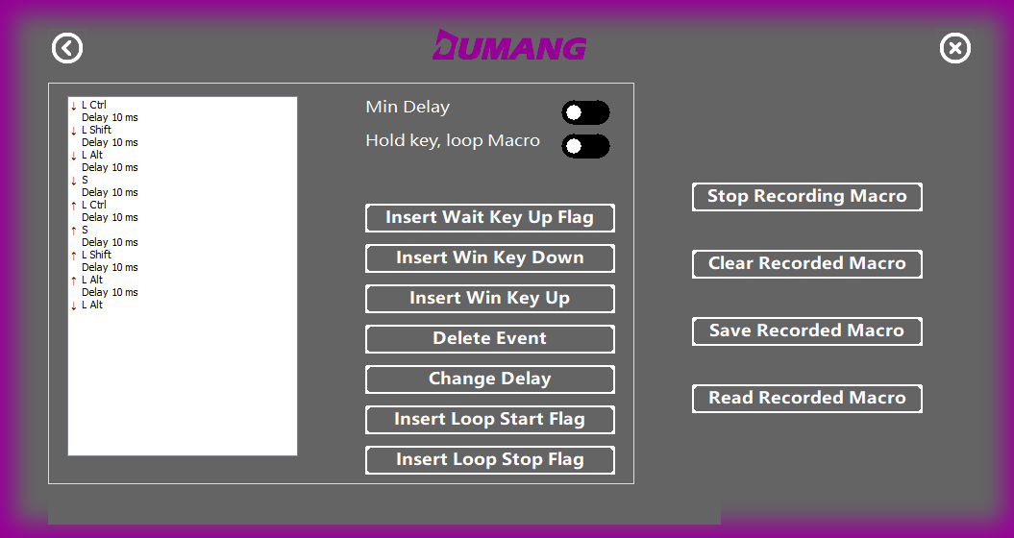
- Step 4: Select the first pop-up button in the above picture which is “ L Alt” and click on “Insert Button pop-up sign” button. It can be done as shown below:
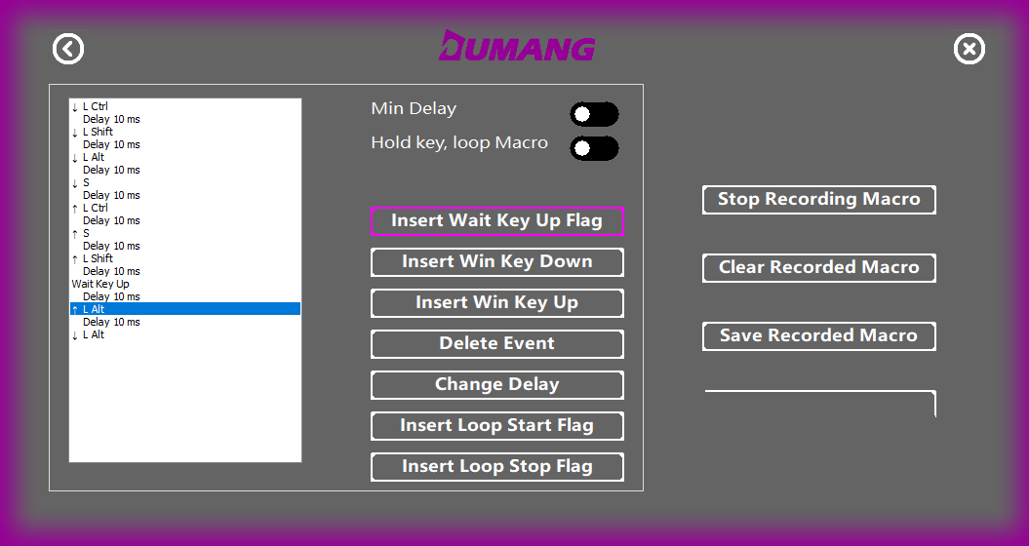
- Step 5: Save the Macro and you are done. The button can now be combined with the S key to achieve the combination of Ctrl + Shift + Alt + S function which the user wants.

